1. public class Question1 {

public static void main(String[] args) {

int a = Integer.*parseInt*(args[0]);

int b = Integer.*parseInt*(args[1]);

int c = Integer.*parseInt*(args[2]);

if(a==b && b==c)

System.*out*.println("Equal");

}

else

System.*out*.println("Not Equal");

}

}

2.

public class Question2 {

public static void main(String[] args) {

int[] bn = {0,1,1,0,1,1,0,1,0,0};

int count = 0;

for(int i=0;i<bn.length;i++){

if(bn[i]==0)

count++;

}

for(int i=0;i<bn.length;i++){

if(i<count){

bn[i]=0;

System.*out*.print(bn[i]+ “ ”); }

else{

bn[i]=1;

System.*out*.print(bn[i]+ “ ”);}

}

}

}



3.public class Q3 {

public static void main(String[] args) {

int n=Integer.*parseInt*(args[0]);

for(int i=0;i<n;i++){

if(Math.*pow*(2,i)<=n)

System.*out*.println((Math.*pow*(2,i));

else

break;

}

}

}

4.

|  |  |
| --- | --- |
| Post increment | Pre increment |
| If we want to assign a current value in our statement and then increment the value by 1, we use a post increment operator.  Example -  int a=10;  int b=a++; // the value of a will be 11, and that of b will be 10. | If we want to increment the value by 1 and then assign that value in our statement, we use pre increment operator.  Example -  int a=10;  int b=++a; // the value of a will be 11, and that of b will also be 11. |

5. We can use logical conditions in a for loop to update several variables within a loop or in the case where one variable is dependent on another. For example,

for(int x=0,y=1;x<10;x++,y*=x){

System.out.println(y);}

6. Yes, we can use double variables as a loop control variable, and can also increase it by fractional values.

7. No, there isn’t a necessity to use for loop instead of while loop or vice versa in any cases. However, in cases where you have to check through every increment ( like running through an array) or do a loop continuation test, it is appropriate to use a for loop.

In cases where you don’t know how many times you need to run the loop but need to perform a set of operations till a certain condition is met, you use a while loop.

In all the cases, you can modify for loop or a while loop.

8.

package com.company;

public class Q8 {

public void sort(int arr[])

{

int n = arr.length;

for (int i = n / 2 - 1; i >= 0; i--)

heapify(arr, n, i);

for (int i = n - 1; i > 0; i--) {

int temp = arr[0];

arr[0] = arr[i];

arr[i] = temp;

heapify(arr, i, 0);

}

}

void heapify(int arr[], int n, int i)

{

int largest = i;

int l = 2 * i + 1; // left = 2*i + 1

int r = 2 * i + 2;

if (l < n && arr[l] > arr[largest])

largest = l;

if (r < n && arr[r] > arr[largest])

largest = r;

if (largest != i) {

int swap = arr[i];

arr[i] = arr[largest];

arr[largest] = swap;

heapify(arr, n, largest);

}

}

void bubbleSort(int arr[])

{

int n = arr.length;

for (int i = 0; i < n-1; i++)

for (int j = 0; j < n-i-1; j++)

if (arr[j] > arr[j+1])

{

int temp = arr[j];

arr[j] = arr[j+1];

arr[j+1] = temp;

}

}

void printArr(int arr[])

{

int n = arr.length;

for (int i=0; i<n; ++i)

System.*out*.print(arr[i] + " ");

System.*out*.println();

}

public static void main(String args[])

{

Customer ob = new Customer();

int a[] = {234, 34, 24, 12, 22, 1, 99};

ob.bubbleSort(a);

System.*out*.println("Sorted array using bubble sort");

ob.printArr(a);

ob.sort(a);

System.*out*.println("Sorted array using heap sort");

ob.printArr(a);

}

}

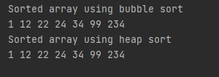

9.import java.util.Scanner;

public class Customer {

public static void main(String args[])

{

int year;

System.*out*.println("Enter an Year :: ");

Scanner sc = new Scanner(System.*in*);

year = sc.nextInt();

if (((year % 4 == 0) && (year % 100!= 0)) || (year%400 == 0))

System.*out*.println(year+" is a leap year");

else

System.*out*.println(year+" is not a leap year");

} }

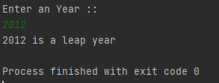

10.

import java.util.Scanner;

public class Q10{

public static void main(String []args) {

Scanner obj=new Scanner(System.in);

int x,y,hcf;

x=obj.nextInt(); y=obj.nextInt();

hcf=gcd(x,y);

System.out.println("Gcd of "+x+" and "+y+" is: "+hcf);

}

public static int gcd(int x,int y)

{

if (y == 0)

return x;

return gcd(y, x % y);

}

}

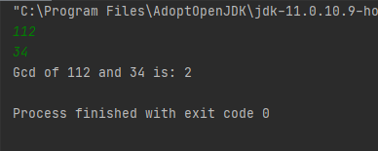

11.

import java.util.Scanner;

public class Q11 {

public static void main(String[] args) {

Scanner obj=new Scanner(System.*in*);

System.*out*.println("Enter a number.");

int n=obj.nextInt();

*decBin*(n);

}

public static void decBin(int n)

{

int []bin=new int[1000];int j=0;

while(n>0)

{

bin[j]=n%2;

n=n/2;

j++;

}

for(int i=j-1;i>=0;i--)

{

System.*out*.print(bin[i]);

}

}

}

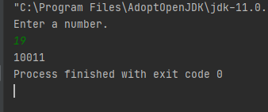

12.

import java.util.Scanner;

public class Q12 {

public static void main(String[] args) {

Scanner obj=new Scanner(System.*in*);

System.*out*.println("Please enter a number");

int n=obj.nextInt();

*checkers*(n);

}

public static void checkers(int n)

{

for(int i=1;i<=n;i++)

{

for(int j=1;j<=n;j++)

{

if(j%2==1)

System.*out*.print("* ");

}

System.*out*.println();

}

}

}

